

**Welcome to "Clocked by Jerry" –** A one-of-a-kind shop offering **exclusive vintage-style cuckoo clocks** inspired by the timeless antics of Tom and Jerry. Our collection features **unique designs** that capture the playful essence of the iconic cartoon, from whimsical chases to hilarious escapes. Each clock is crafted with **attention to detail and nostalgic charm**, making them perfect for collectors and fans alike.

Discover a **variety of designs, limited editions, and rare finds** that bring the spirit of cat-and-mouse mischief into your home.

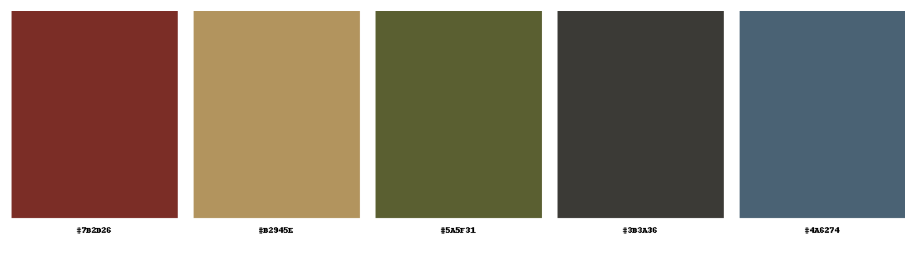

| **Hex Code: #7B2D2D** | **Hex Code: #9B8250** | **Hex Code: #4E532A** | **Hex Code: #3B3A36** | **Hex Code: #4A6274** |
| --- | --- | --- | --- | --- |

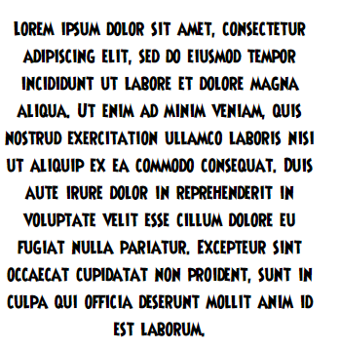





Logo Designs

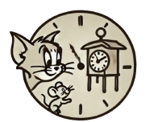

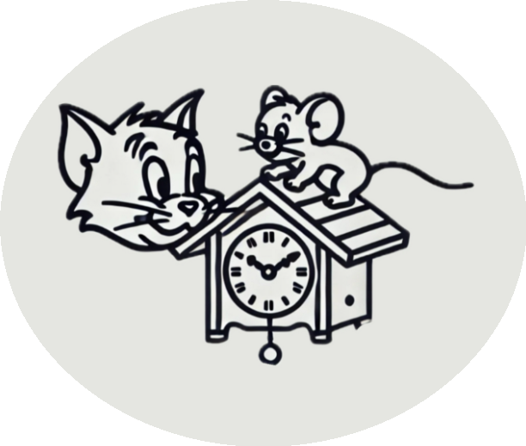

Sample Pictures

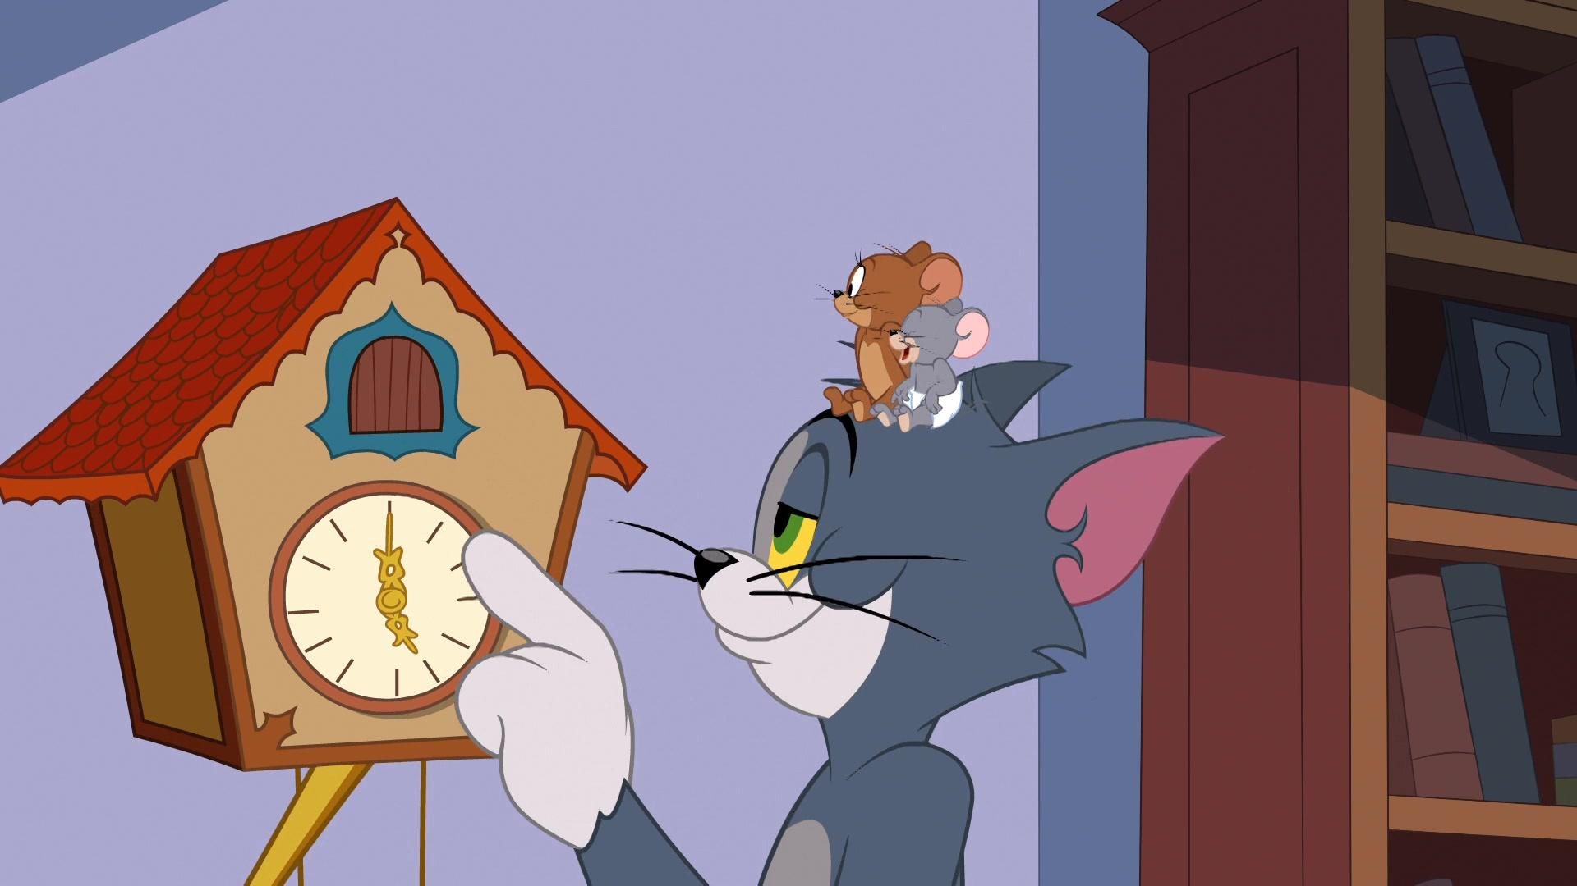

https://www.imdb.com/title/tt9626396/

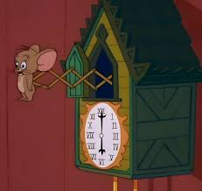

<https://www.facebook.com/groups/classiclooneytunes/posts/926426672426119/?_rdr>

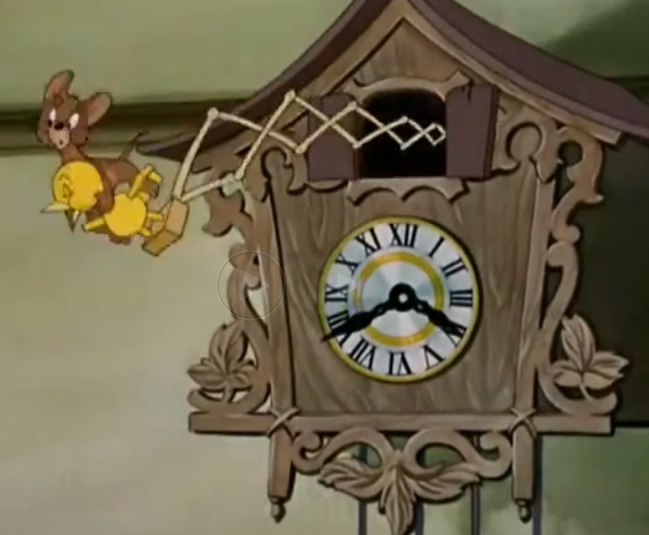

<https://www.dailymotion.com/video/x191dxm>

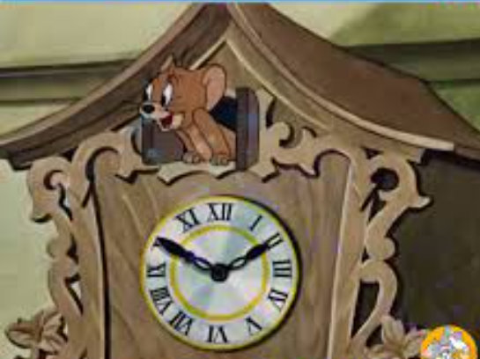

<https://www.facebook.com/100043007932429/videos/tom-and-jerry-cartoon/306692747499661/>

https://www.youtube.com/watch?v=o6gkjr42v_E&ab_channel=%28WINTER%29JoshuaTsegah